*Passive-Aggressive Algorithm*

Passive-Aggressive algorithms are generally used for large-scale learning. .In online machine learning algorithms, the input data comes in sequential order and the machine learning model is updated step-by-step, as opposed to batch learning, where the entire training dataset is used at once. This is very useful in situations where there is a huge amount of data and it is computationally infeasible to train the entire dataset because of the sheer size of the data. We can simply say that an online-learning algorithm will get a training example, update the classifier, and then throw away the example.

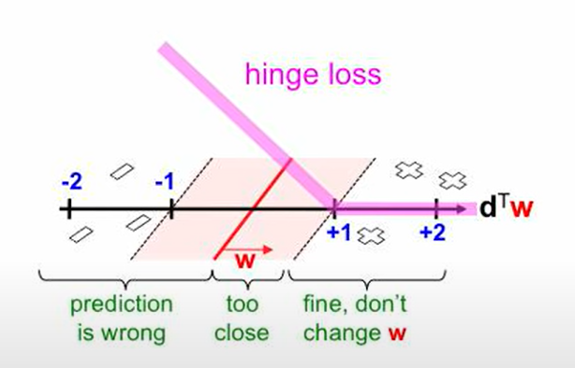

Passive-Aggressive algorithms are generally used for large-scale learning. .In online machine learning algorithms, the input data comes in sequential order and the machine learning model is updated step-by-step, as opposed to batch learning, where the entire training dataset is used at once. This is very useful in situations where there is a huge amount of data and it is computationally infeasible to train the entire dataset because of the sheer size of the data. We can simply say that an online-learning algorithm will get a training example, update the classifier, and then throw away the example.

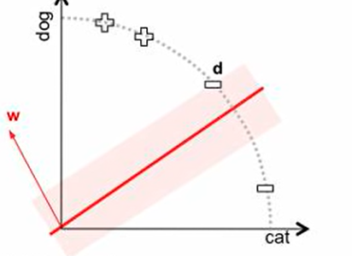

Passive: if correct classification, keep the model; Aggressive: if incorrect classification, update to adjust to this misclassified example.

**Important parameters:**

* C : This is the regularization parameter, and denotes the penalization the model will make on an incorrect prediction
* max_iter : The maximum number of iterations the model makes over the training data.
* tol : The stopping criterion. If it is set to None, the model will stop when (*loss > previous_loss  –  tol*). By default, it is set to 1e-3.

The dataset that I am using to implement this algorithm is based on advertising of a product where our task is to predict the sales of the product based on the amount we are spending on different sources of advertising our product. So below is how you can implement this algorithm to [**predict the sales**](https://thecleverprogrammer.com/2021/05/19/sales-prediction-with-machine-learning/) of the product using Python:

*The additive PA algorithm*

Parameter: Insensitivity:

Initialize: Set w1 = 0 (R&C) ; w1 = x0 (U)

For t = 1, 2, . . .

• Get a new instance: zt ∈ R

n

• Suffer loss: `(wt; zt)

• If `(wt; zt) > 0 :

1. Set vt (see Table 1)

2. Set τt =

`(wt;zt)

kvtk2

3. Update: wt+1 = wt + τtvt

**Summary**

So this is how you can implement a passive aggressive strategy to solve machine learning problems. It belongs to the category of online learning in machine learning. It is not one of the most commonly used machine learning algorithms, but it can nonetheless be used to achieve efficient results. I hope you liked this article on the passive aggressive regression algorithm in machine learning and its implementation using Python. Feel free to ask your valuable questions in the comments section below.

___An article by –

Sorbajit Goswami